第一步：在手机浏览器上输入如下网址：
http://litiantai.com/box/download/
Step 1： Enter the following website address in the mobile browser:
http://litiantai.com/box/download/
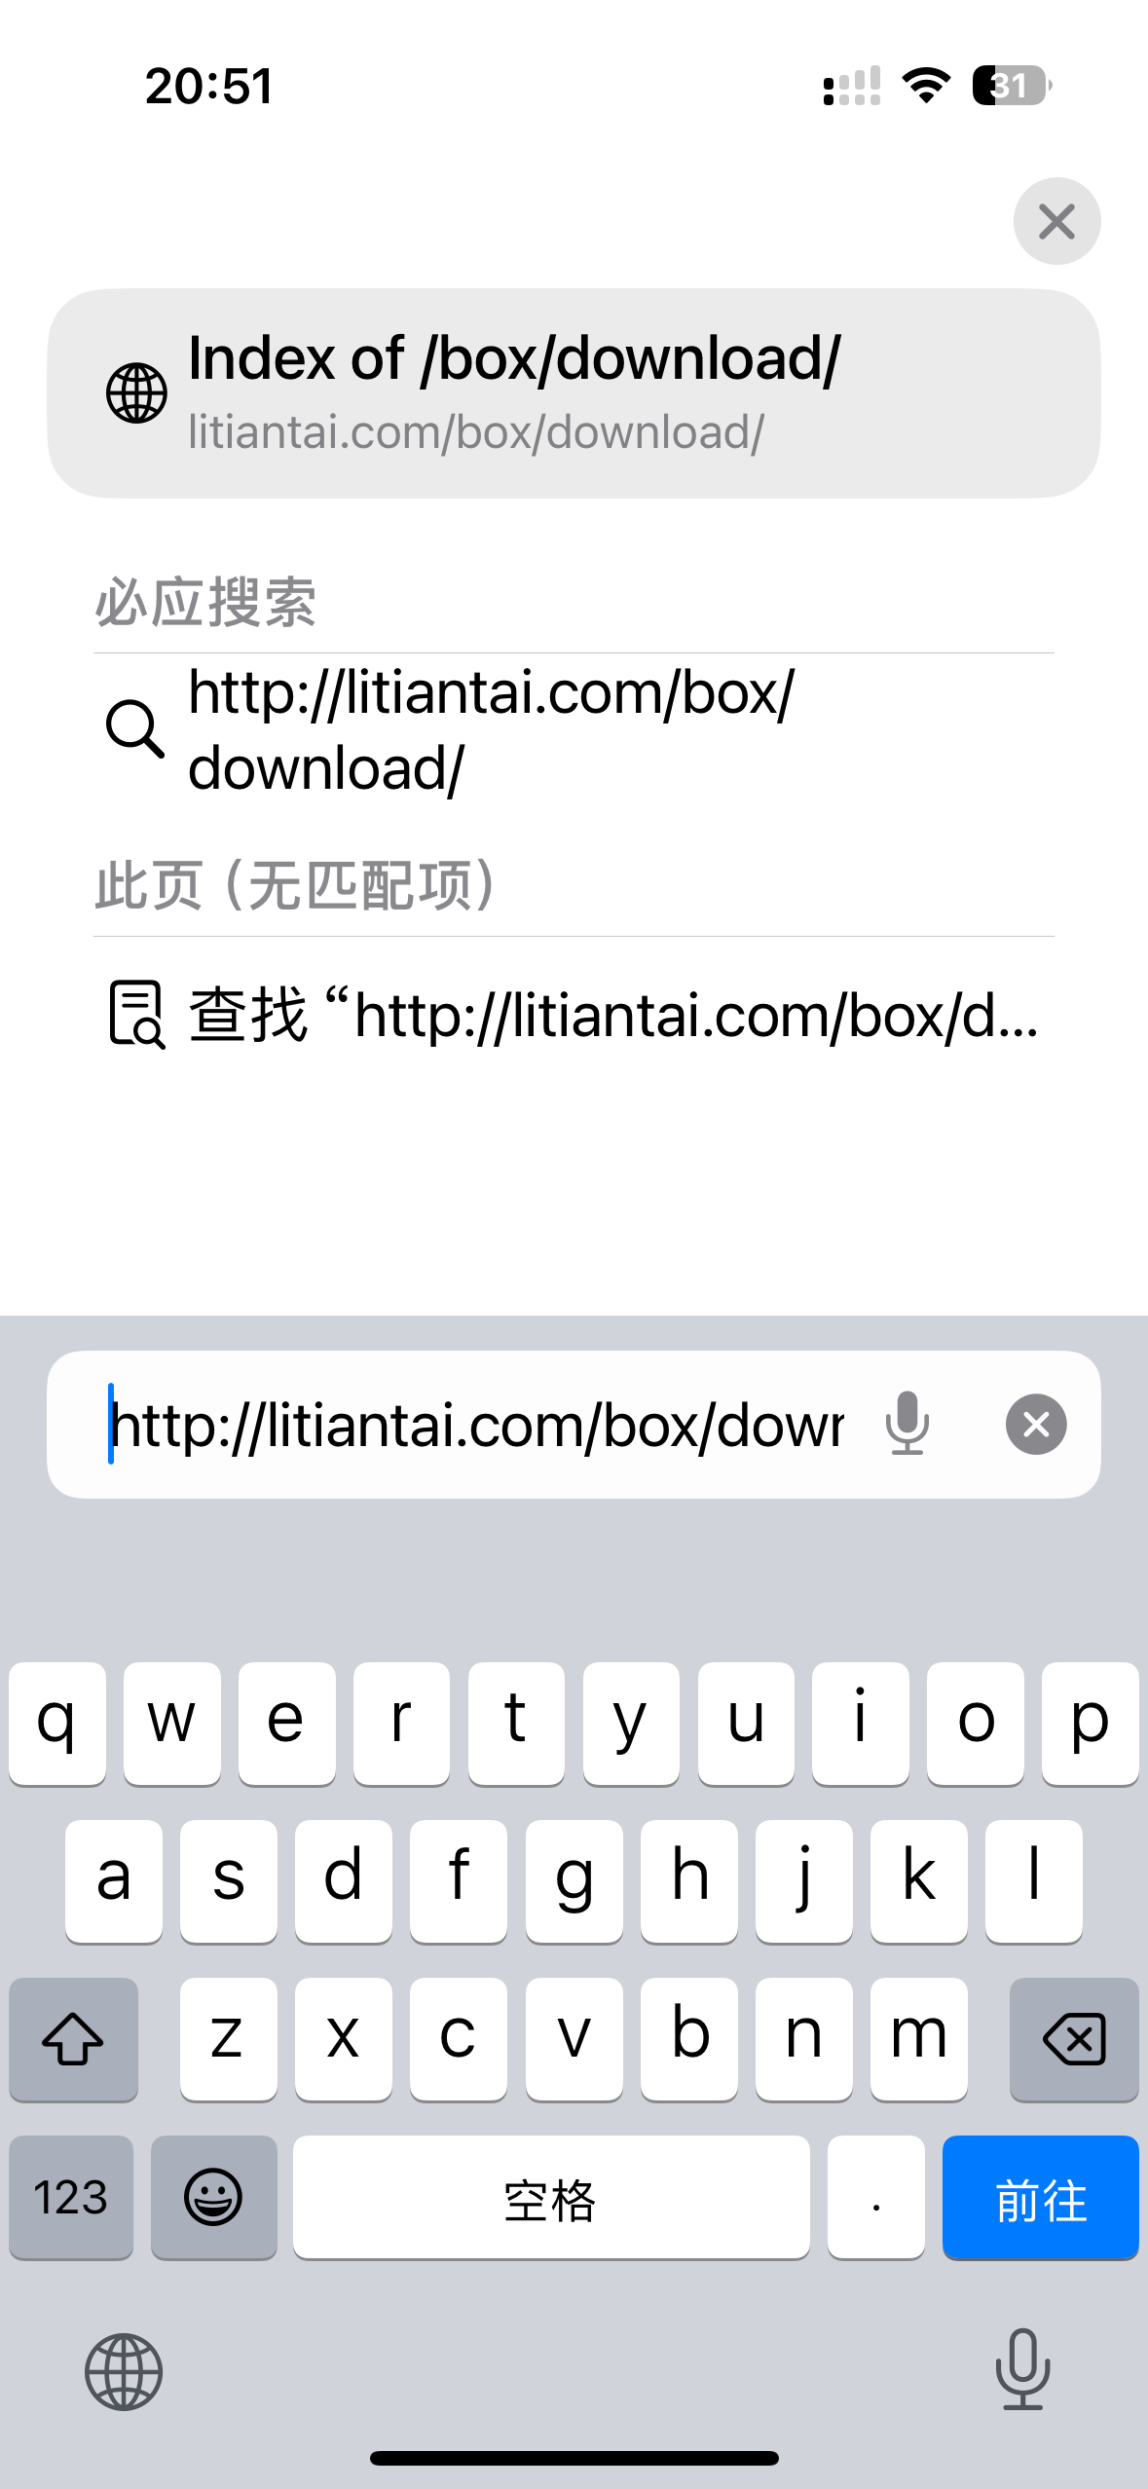

第二步：选择网站中最新日期升级文件并下载到手机上，请记住升级文件在手机上的存储路径；
Step 2: Select the latest date upgrade file from the website and download it to your phone. Please remember the storage path of the upgrade file on your phone;

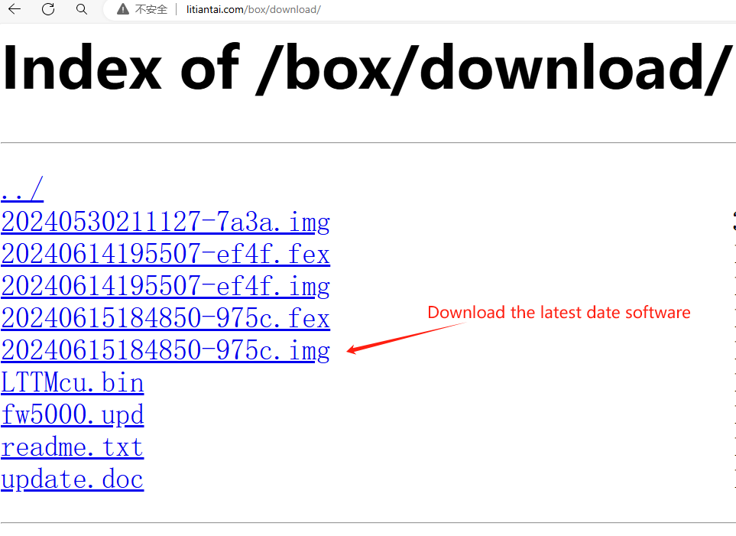

第三步：手机打开wifi设置，搜索盒子wifi（carplay_box_xxx）输入密码：12345678，并连接好wifi；然后在手机浏览器上输入网址：192.168.43.1
Step 3: Open the wifi settings on your phone, search for the box wifi (carplay-box-xxx), enter the password: 12345678, and connect to the wifi; Then enter the website address on the mobile browser: 192.168.43.1
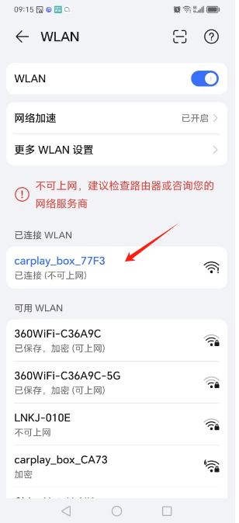

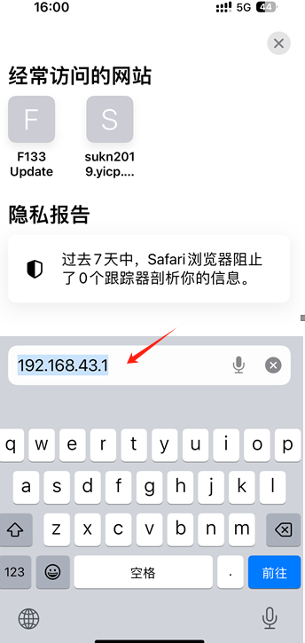
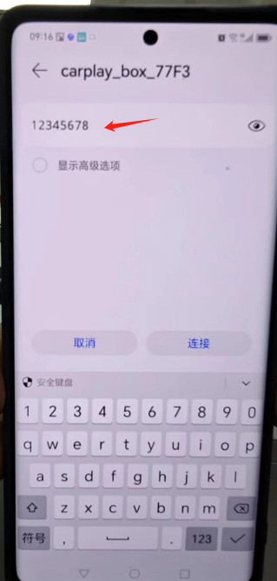

图A 图A-1 图 B

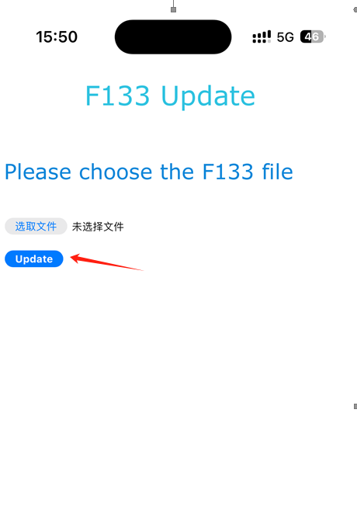
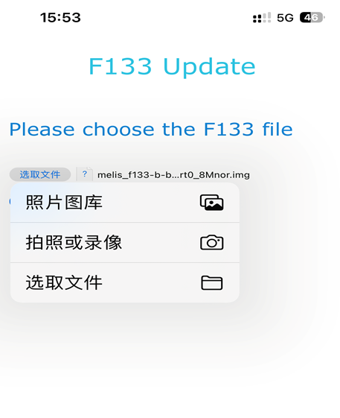

图C 图D

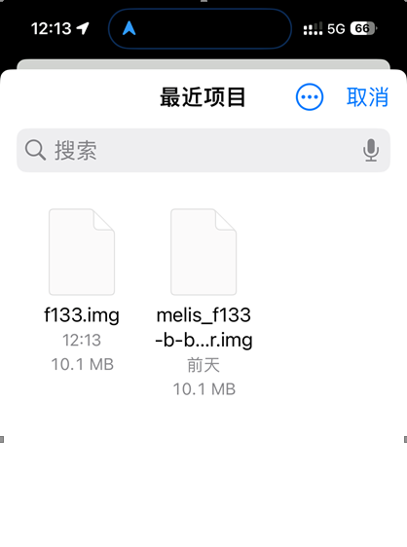
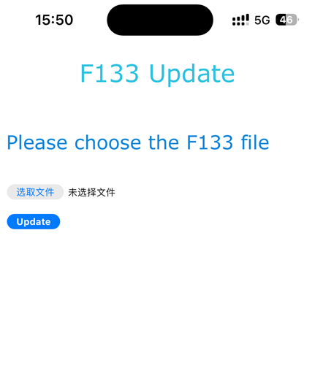

图E 图F
第四步：点击Update 按钮，下载完后手机网页更新状态，等待升级，请勿拔插盒子。
Step 4: Click the Update button. After downloading, update the status of the mobile webpage and wait for the upgrade. Do not unplug or unplug the box.
